Independent India’s First Postmistress

Marking the Family ‘s Centenary in the Capital City Delhi 1909 - 2009

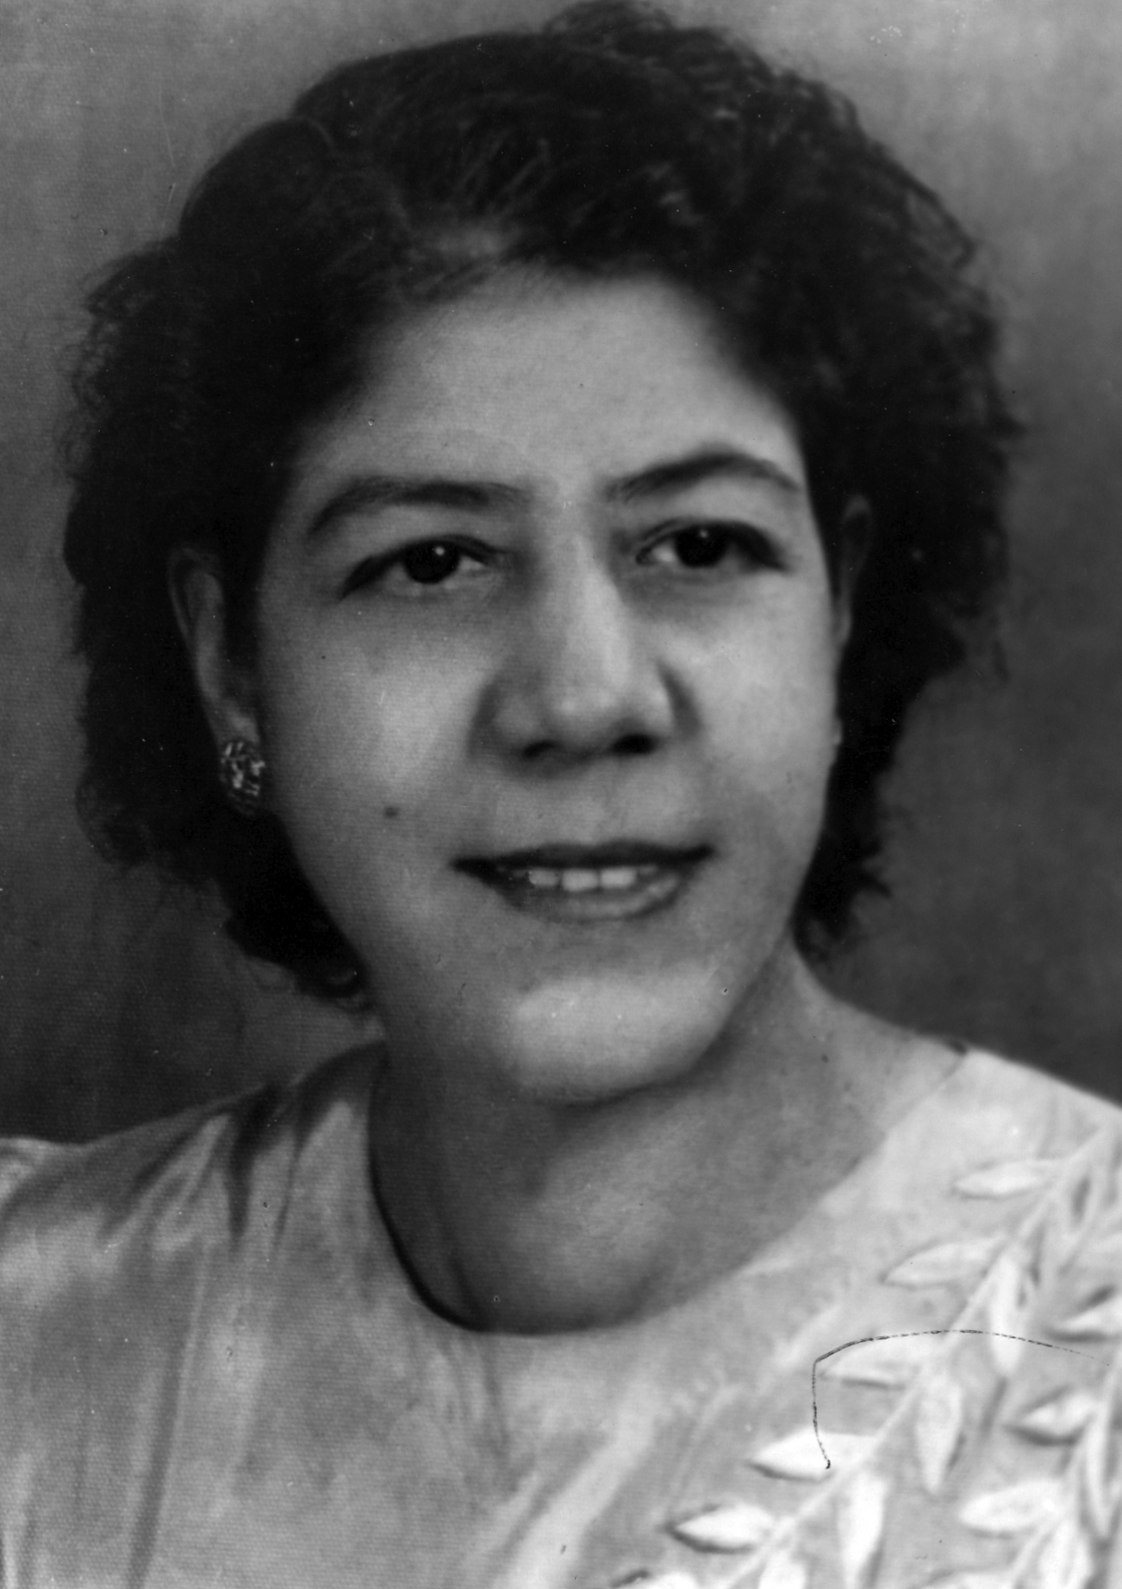

MARY ISAACS REBEIRO
1904 - 1983

Celebrating The pioneering First Postmistress of India
and her distinguished Family
Mary Isaacs Rebeiro 22 October 1904 – 2 November 1983
∗ The first lady to head a Post Office ( Kashmere Gate , Maiden’s Hotel and Mori Gate , from
1940 ) in an all - male Postal environment when less than 1 pc of India’s OrganisedSector
workforce was female and 16 pc Indians were literate .

∗ Affectionately called dak khaneki memsaab by the thousands she served , especially among
illiterates and the weaker sections .

∗ In times when Post Offices were the main , often only , such centres she served Delhi’s
prestigious St Stephen’s Hospital , The Indian Express , Queen Mary ’s, Maiden’s / Swiss Hotels ,
Chief Commissioner - Magistrates / The District Courts , Carlton’s ( commissioned 1922
by Viceroy Daniel Isaacs who also founded Delhi University 1922 ) Jagat Narain Seth ( owner of
Ritz , Novelty and Jagat Cinemas) ace photographerKulwant Roy and eminent writer
Nirad C Chaudhuri , diplomats and foreign tourists in elite Civil Lines – Kashmere Gate –
Mori Gate .

∗ Daughter of distinguished Anglo –Indian parents Sarah Rose and Revd JS Isaacs
( Jt Commissioner Lahore / Delhi’s RevenuesOfficer 1920s )niece of Principal Eric Isaacs MA ,
sister of Grace , Stephen Isaacs MA IAS , John Isaacs MSc , George Isaacs ( DE Telegraphs )
and Theophilus Isaacs ( Electrical Engineer , Sheffield UK ) and cousin of Brigadier Sam Isaacs ,
beloved wife of John Rebeiro ( Delhi 1909 / Delhi Improvement Trust / DDA ) cherished mother of
Jeanette ( Church High , now DPS / Presentation Convent / Trinity School of Music London1940s ) .

∗ Oldest worshipping family of the oldest Church (1836) in Delhi, St James since 1910.

The Isaacs’ , The Dountings and The Stimpsons (UK) The Josephs (Delhi – Bombay )
and son Prof Sydney Rebeiro MA (Delhi) / Cambridge UK / Kentucky USA
Res :A 681 Sarita Vihar New Delhi 110076 R: 26953434 O : 27666665
sydneyrebeiro@yahoo.coand sydneyrebeiro@gmail.com2009

